**Basic Details**

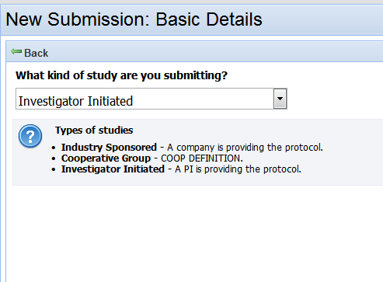

Help Text:

Cooperative Group – Health care institutions that collaborate to develop and implement clinical trials.

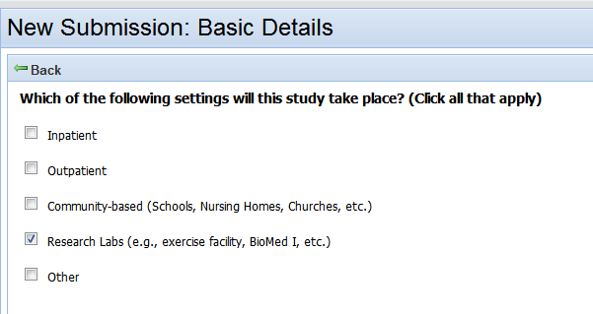

Edit:

In which of the following settings will this study take place?

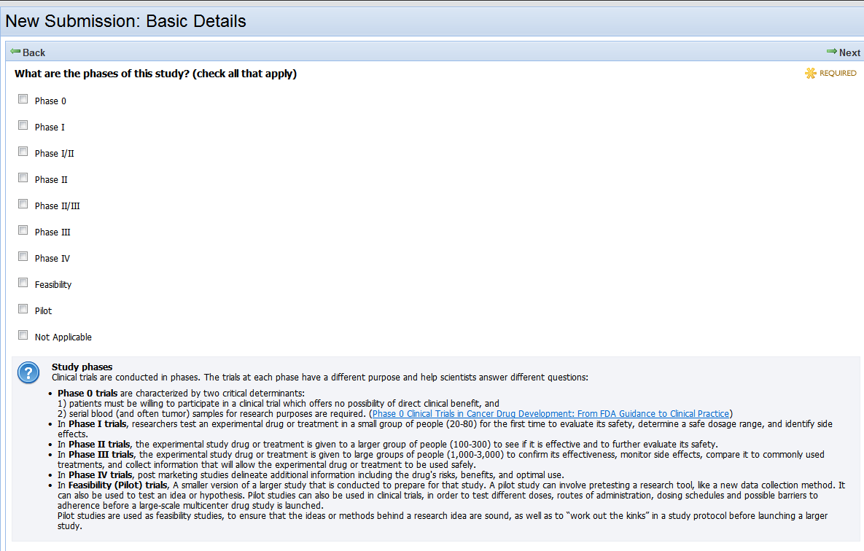

Help Text:

“The trials at each phase have a different purpose and help scientists answer different questions.”

## Can definitions for each phase be changed to hover text?

**Phase 0 trials**

Characterized by two critical determinants:   
1) patients must be willing to participate in a clinical trial which offers no possibility of direct clinical benefit, and   
2) serial blood (and often tumor) samples for research purposes are required. ([Phase 0 Clinical Trials in Cancer Drug Development: From FDA Guidance to Clinical Practice](http://molinterv.aspetjournals.org/content/7/6/325.long))

**Phase I trials**

Researchers test an experimental drug or treatment in a small group of people (20-80) for the first time to evaluate its safety, determine a safe dosage range, and identify side effects.

|  |  |
| --- | --- |
| **Phase I/II trials**  A trial to study the safety, dosage levels, and response to a new treatment. | . |

**Phase II trials**

The experimental study drug or treatment is given to a larger group of people (100-300) to see if it is effective and to further evaluate its safety.

**Phase II/III trial**http://www.cancer.gov/images/spacer.gif

|  |  |
| --- | --- |
|  | A trial to study response to a new treatment and the effectiveness of the treatment compared with the standard treatment regimen. |

**Phase III trials**

The experimental study drug or treatment is given to large groups of people (1,000-3,000) to confirm its effectiveness, monitor side effects, compare it to commonly used treatments, and collect information that will allow the experimental drug or treatment to be used safely.

**Phase IV trials**

Post marketing studies delineate additional information including the drug's risks, benefits, and optimal use.

**Feasibility trials**

Used in order to test different doses, routes of administration, dosing schedules and possible barriers to adherence before a large-scale multicenter drug study is launched.

|  |
| --- |
| **Pilot trials**  The initial studies examining a new method or treatment. |

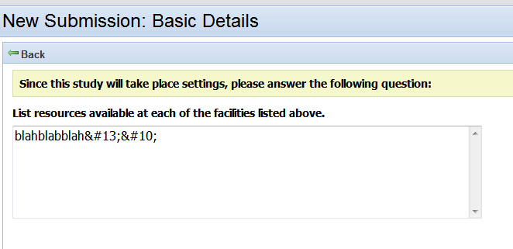

Edit:

Remove text “Since this study will take place settings, please answer the following question:”

Change to “List the resources available in the selected settings.”

Help Text:

Resources: Include staff, equipment, materials, and supplies that will be made available to the researcher, such as computer and office equipment, specimens, repositories, databases, registries, and software.

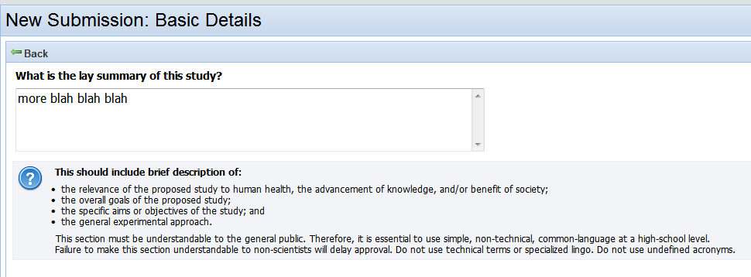

Help Text:

Add text, “The lay summary can usually be taken from the informed consent document.”